**Ex 21-1 # 1:**

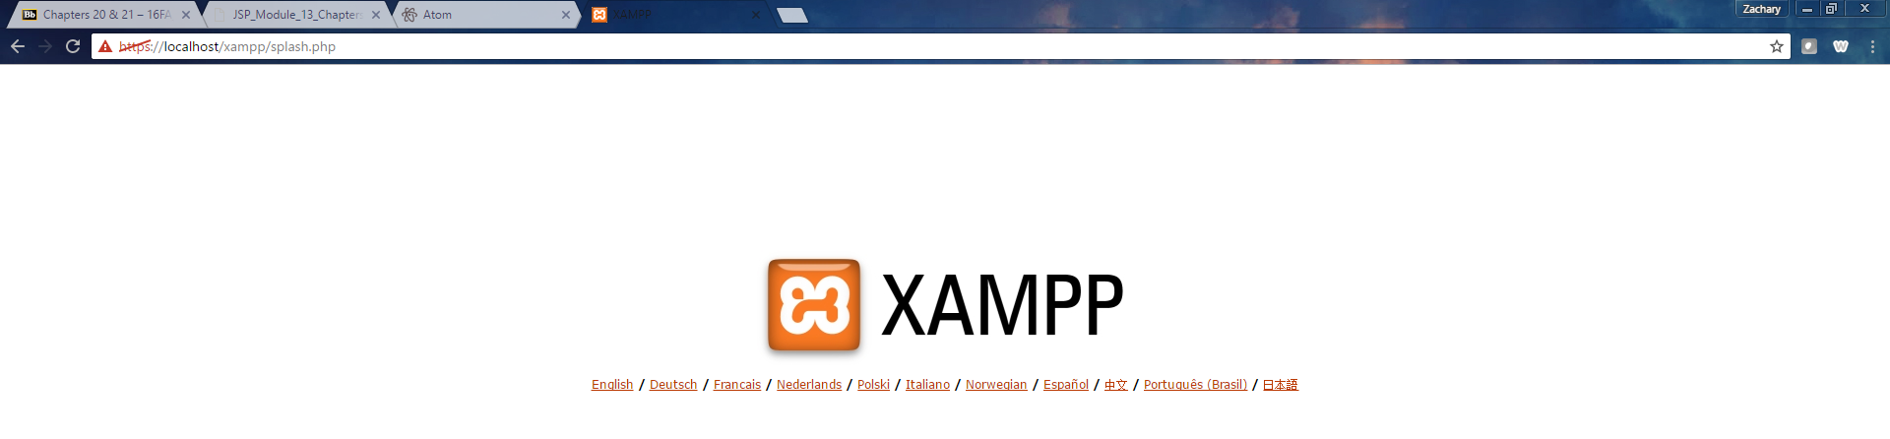

*Able to access* [*https://localhosts/*](https://localhosts/) *successfully.*

**Ex 21-1 #2:**

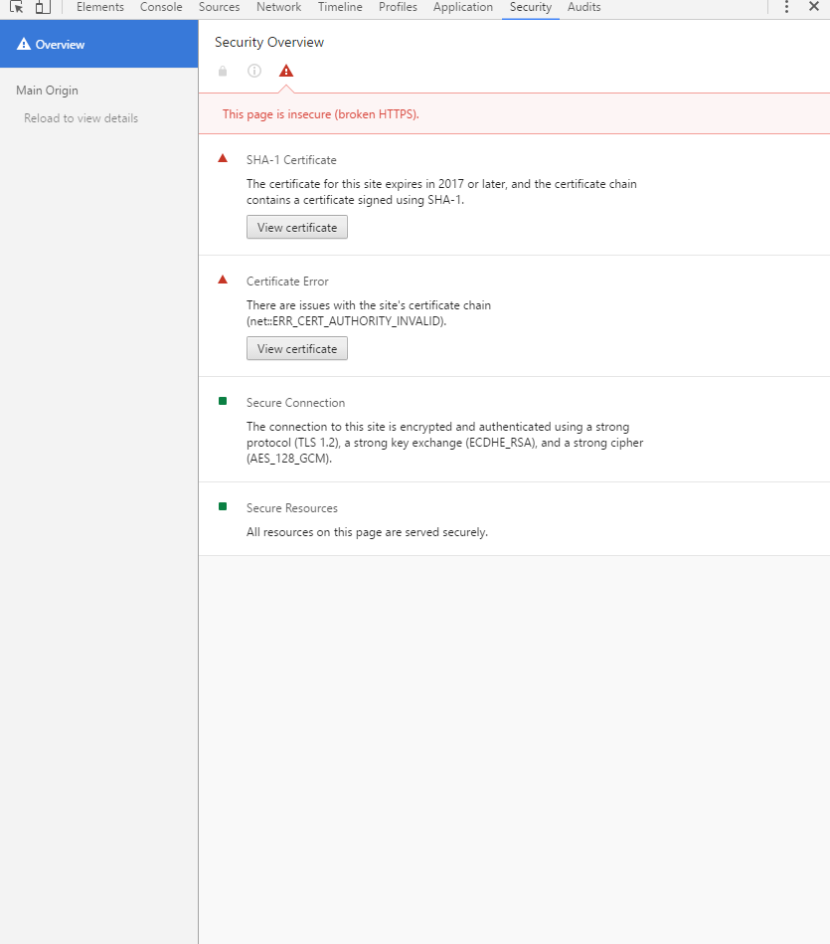

*Able to view security information about the site and view certificates.*

**Ex 21-1 #3:**

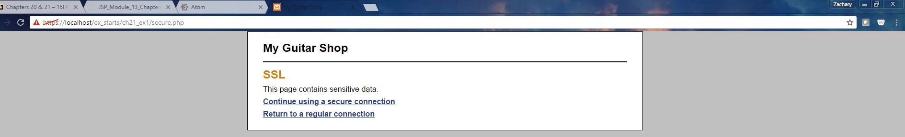

*This page properly uses a secure connection.*

**Ex 21-1 #4:**



*No matter what it still must use https.*

**Ex 21-1 #5:**

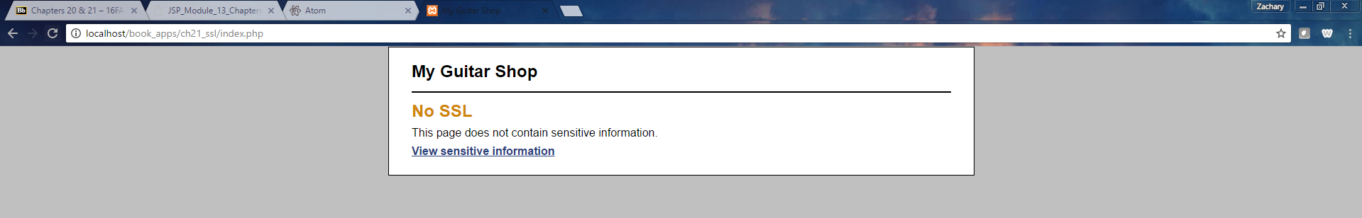

*When you click return to a regular connection you are no longer on a secure connection.*

**Ex 21-1 #6:**

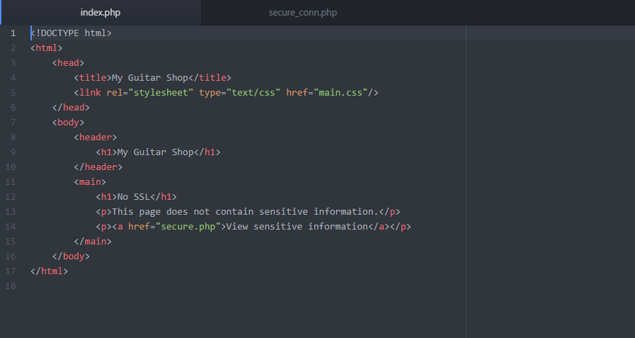

*Uses a relative URL.*

Ex 21-1 #7:

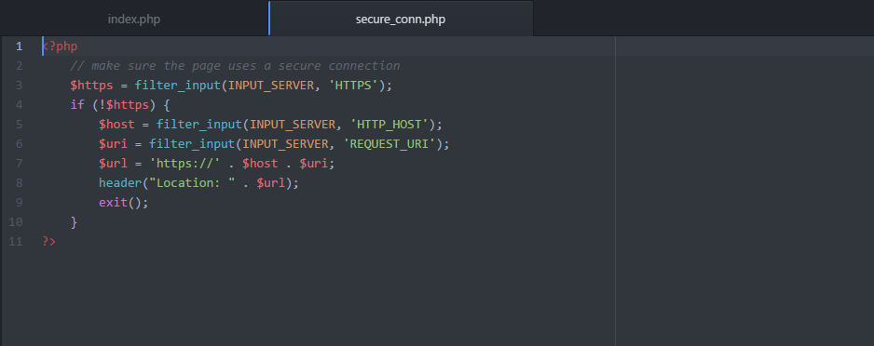

*This uses an absolute URL.*

**Ex 21-2 #1:**

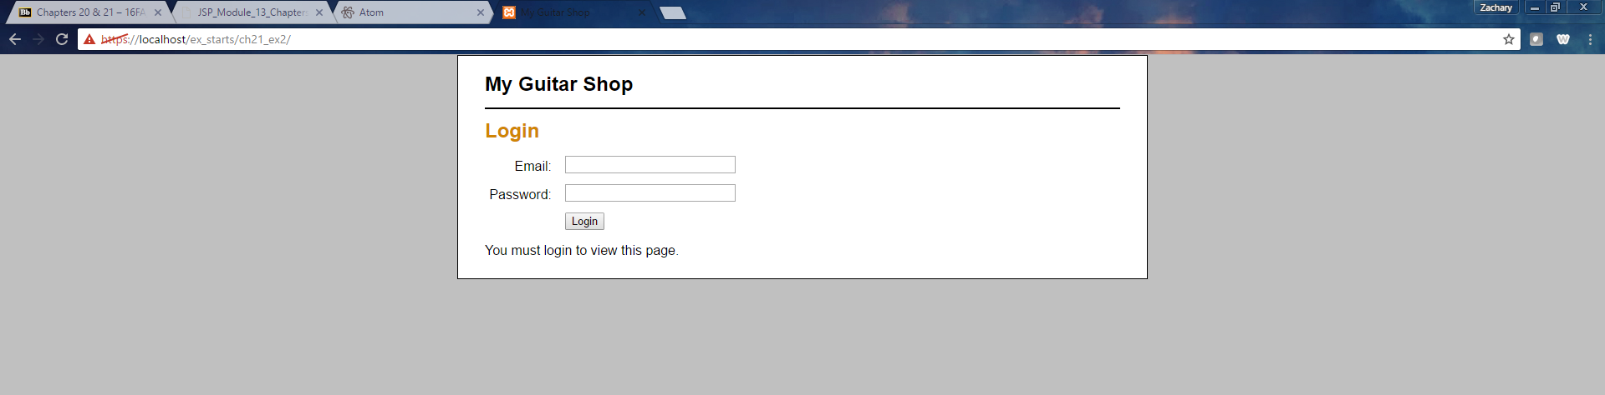

*Able to run the application.*

**Ex 21-2 #2:**



*When you input invalid login info it just reloads the page.*

**Ex 21-2 #3:**

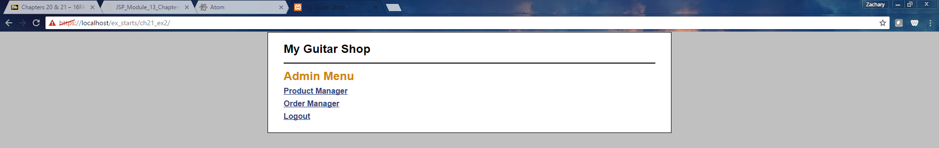

*This lets you login if you use valid login information.*

**Ex 21-2 #4:** 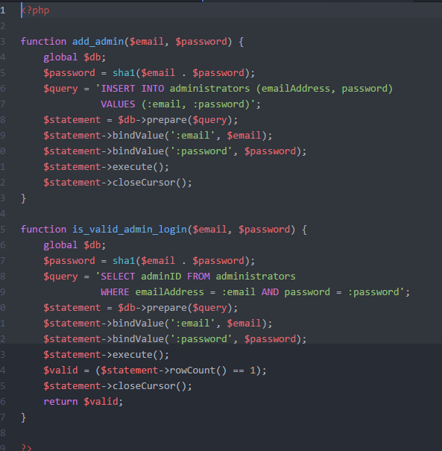

*This uses the sha1 function to encrypt email/password.*

**Ex 21-2 #5:**

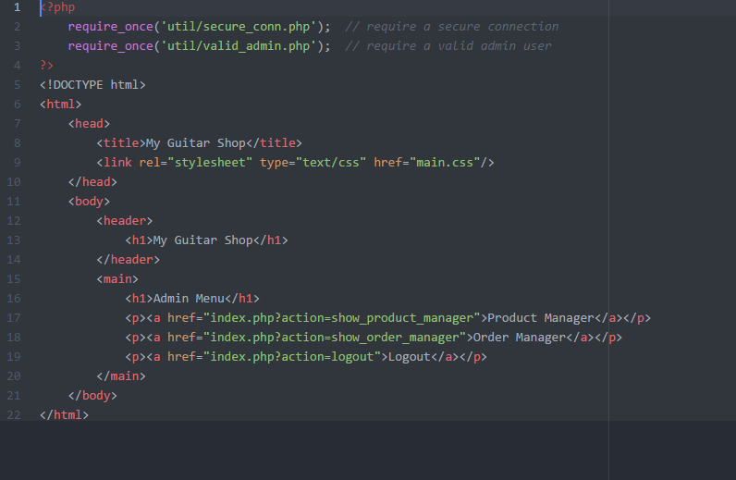

*These require a secure connection and valid admin user.*

**Ex 21-2 #6:**

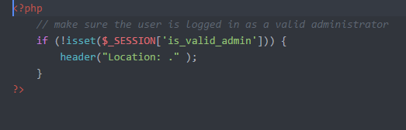

*Redirects to the controller if the user in’s t a valid admin user.*

**Ex 21-2 #7:**

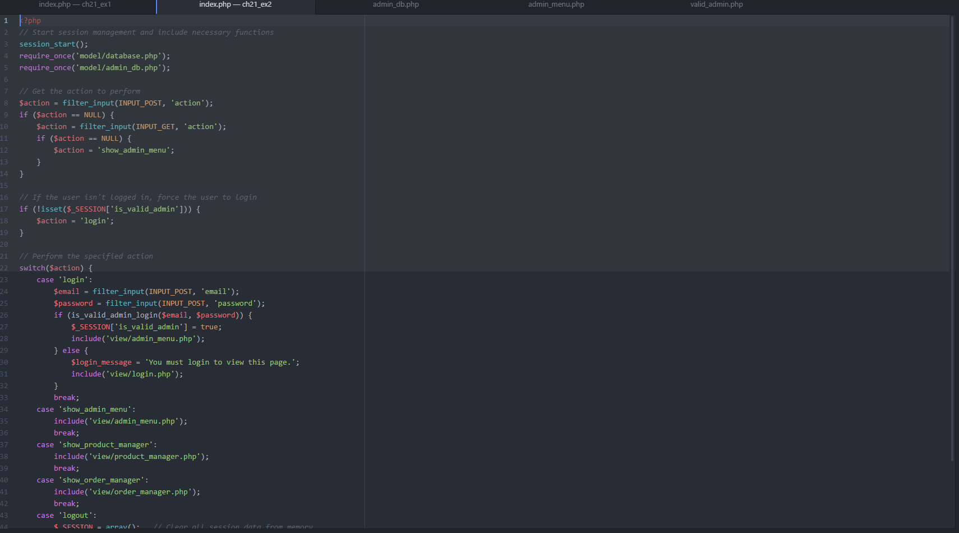

*Performs appropriate action if user is not valid admin.*